**Proposal Document** | Team 7

Executive Summary

“£850 million is spent on North Sea energy logistics every year and chartered vessels spend 50% of their time not in use”. This quote from Oil and Gas Authority UK inspired us, Team 7, to think about the solution for the enormous amount of money wasted on vessels that are not needed all the time. We would like to introduce to you SpaceShips.

Our project is addressed to the oil and gas industry in the UK North Sea, especially to every operator who wants to save, or even make money. SpaceShips will be a software that will facilitate vessel sharing between operators. The careful market research we conducted on the topic showed that there is a need for this kind of service. Even if there is a competition for us in the industry, our product will have several advantages over them, such as broadly defined accessibility.

This project involves mainly software development. As our team is able to handle both designing and building said software, the funding we hope to receive would be spent on other expenses, like obtaining AIS data (which is fundamental to the operation of SpaceShips), maintaining the application and marketing. We plan to offer SpaceShips’ users a monthly subscription charge of £1,000 and take a 10% cut of every share made by operators. We expect the investment to pay off in the near future after launching of our application.

Table of Contents

1. Introduction 1
2. Concept 2
3. Use Cases and Benefits 3
4. Research
   1. Market Research 3
   2. Technical Research 4
5. Case for £10K
   1. Project Plan 5
   2. Risk Analysis 6
6. Conclusion 6
7. Bibliography 6
8. Appendices 7

Introduction

It is estimated that the North Sea spends in excess of £850 million per annum on marine logistics for the operation of offshore installations. (1) This figure excludes any spend on capital projects and decommissioning activities. North Sea operators typically contract with one of two main marine logistics contractors who in turn provide a combination of both onshore supply bases and supply vessels who will transfer goods and materials between the key marine ports (Aberdeen, Peterhead, Kington-upon-Hull) and their offshore installations. Costs can be variable and can either be locked in through long term contracts or equally operators can access vessels through the spot market during periods of high demand or equally when emergent issues (e.g. production outages) drive an immediate need. Based on 2018 demand, spot market rates varied between £7,500 and £15,000 per day dependant on boat size and class. (2)

Vessel deck space and vessel routing are two known factors which drive inefficiency into the supply vessel market. It is estimated that vessel utilisation could increase by up to 50% as a consequence of more efficient vessel routing and better deck loading. The main issue and impediment to such an improvement which would inherently drive the cost of offshore operations down is that platform operators do not have immediate access and knowledge of spare vessel capacity across the North Sea, regardless of any contractual constraints.

With the introduction of SpaceShips, operators will be able to improve vessel utilisation without the need for extensive planning and collaboration amongst operators as well as the supply chain. Current behaviours in the industry continue to drive combative behaviours between marine logistics providers. Similarly, operators continue to prioritise their own needs over the broader needs of the industry to be more cost efficient. Operators will also be able to post their requirements onto SpaceShips (similar to hailing a taxi) and await a response from nearby vessels. By optimising the number of active vessels in the North Sea, not only will operators reduce their costs, but vessel emissions will also be reduced. According to the International Maritime Organisation, shipping emissions account for approximately 2.5% of global greenhouse gas emissions and this is expected to rise to 6.3% by the year 2050 if no changes are made. (3)

Concept

Our project’s name, SpaceShips, perfectly describes the main theme of our concept. We decided to take the challenge of literally making something out of nothing – in our case making a profit from spare deck space on ships. The logo of our project is also an interesting element. It depicts an origami paper boat, which reflects the simplicity we want to achieve with our software.

The software we are offering is designed to make sharing vessels in the North Sea quicker, simpler and more available. By using live data (provided by Automatic Identification Systems technology) about the current position and destination of nearby vessels, our application will allow requesting pickups or deliveries, suitable for the cargo and the carrier’s capacity.

Keeping in mind the fact that one of our priorities is to help operators save time, the user interface of our software is intended to be modern, yet easy to navigate. One of the main parts of the software will be a map where the passing by ships can be viewed, a filter used for searching vessels by company and position in time to add your own vessels to the system. The other significant part is a built-in inter operator communication system that allows users to negotiate, accept offers and seal bids by making payments directly with each other.

Currently, our main target is the North Sea oil and gas industry, but we believe our concept can be extended to other industries such as offshore wind and other geographic regions. As we grow, we aim to spread our presence and eventually become a worldwide company.

Use Cases and Benefits

SpaceShips would help cut costs and boost efficiency in the North Sea oil and gas industry. With what is available just now, operators have to pay large sums of money to rent a vessel, approximately £7,500 to £15,000 per vessel depending on capacity and class. However, such vessels are not always fully utilised with spare capacity available to other prospective customers. The SpaceShips business model would require a licence fee of £12,000 per year per operator and an agreed fee for every vessel accessed through use of the software. Significant cost efficiencies could be realised as a consequence. Even a 5% improvement in efficiency could reduce the cost to operators by up to £43 million per annum.

SpaceShips will allow operators to access ad-hoc vessels. Rapid changes in North Sea weather can cause an unexpected demand for supplies or transportation of resources and our software will provide a fast, reliable and cost-effective solution, which will help boost productivity. It may also reduce waiting time for vessels as operators are able to use passing vessels rather than waiting for vessels to arrive from a marine harbour.

Another benefit of SpaceShips is that it will help the environment. With global warming a growing concern, driving efficiency into offshore operations is increasingly relevant. Our software will help ensure that less vessel time is needed and therefore reduce CO2 emissions.

Market Research

We conducted market research in order to give our team an idea of what differences our project could make in the UK oil and gas industry, and if it would be a large enough market for us to put our resources into. It was found that in 2017 the cost of logistics and admin was roughly £1.7 billion, which consisted of marine and air logistics between ports and facilities as well as insurance. Assuming that around 50% of this figure was spent on marine logistics, this would bring the cost to around £855 million. (1) Following an independent interview with an employee of the oil and gas industry, it was found that between unutilised deck space and idle vessels, ships were running at an efficiency of approximately 50% and as such operators are overspending by approximately £300 million.

The latest data suggests that around 185 platforms are currently operating in the UKCS with 58 operators controlling the area. If every operator used our service, we would generate £696,000‬ each year from rental costs at £1,000 a year which is not including the 10% cut of each share made using our software. The day rates for renting offshore supply vessels appear to be around £7,500 for anything bigger than 750 square meters of deck space (2) and when a company may not even need that amount of space, they would be wasting money because of the empty space.

There is also another similar service currently in the market called PlanSea which has functions consisting of voyage reporting, fleet planning, vessel scheduling and reactive schedule. However it seems to be that they currently have no way for operators to communicate with each other using their service. A drawback of this service is that it requires a lot of collaboration between operators instead of being fully automated.

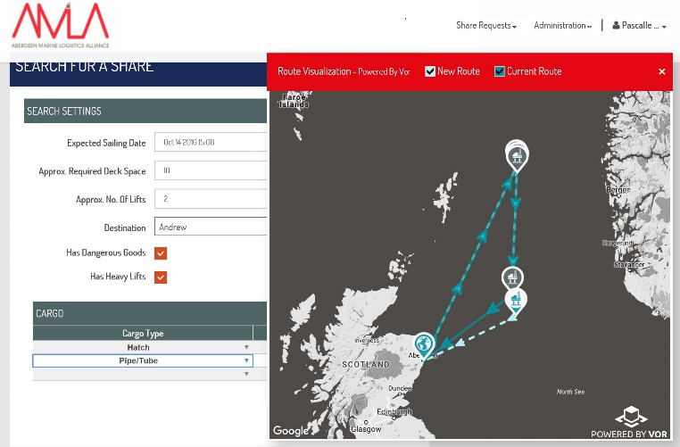There is another service developed by Streamba Ltd on behalf of the marine logistics company Peterson which is also a vessel sharing software that allows operators to share deck space to save CO2 emissions and cut costs (12). The drawback to this software is that users are required to be a member of AMLA and it is built as a web-based application allowing for far less functionality.

We have decided to perform user testing on our products to gain feedback on the user interface and the functionality of the service so we can make necessary changes to increase ease of use for the end user. The team has also spoken to many people from the oil and gas industry about our product and in general feedback has been positive. Such a comment comes from North Sea operator Chrysaor:

“Definitely can see that operators would benefit particularly as they reduce their presence in any specific area.”

Technical Research

To develop our application, multiple factors in terms of accessibility and data management need to be considered. Firstly, different operating systems used by all devices have been evaluated in order to choose the most suitable programming language. In order to develop a native application (specifically designed to work on a certain device and OS) we chose to use the open source programming language Java, that is one of the main programming languages widely used by Apple (IOS) and Google (Android).(4) Worldwide, around 74% of mobile devices are Android, 23% are IOS and the remaining 3% use other operating systems.(5) This will give us many advantages, like the possibility to develop a mobile version of our app without many changes, and the fast and responsive software performance which makes SpaceShips a high-quality application that will be appreciated by users.

Another challenge in terms of accessibility is having the application available in multiple languages. English will be the main language, but we expect to have users of various nationalities and we want to give the best experience to everyone. This means we must create a graphical interface that can be inoffensive to any nationality or religion and above all, ensure a correct translation and etiquette to each language. In order to achieve the best output, we aim to make use of human translation, thus avoiding the errors and inaccuracies common to machine translation. (6) With the skillset of our team we will currently be able to have our application ready in English, Polish and Italian.

For what concerns data management, we first of all need to have access to AIS data in order to facilitate the vessel tracking and monitoring. This will be bought from a specialized agency; however, our long-term aim is to launch our own AIS satellites. We will also need web servers to manage the data traffic and database servers to store AIS and user data. This will allow us to keep track of all the agreements made within our application and to study eventual incidents or delays occurred, as well as shipping routes and application performance. We must also consider the GDPR when handling company specific data and as such we will make sure to outsource our servers to a reputable and well-known host, along with writing our own statement to pledge our compliance.

Thanks to this research we will be able to guarantee a continuous efficiency improvement and a profitable expansion of SpaceShips. Looking at some numbers, to develop a multi-platform application, an app development company would require about 1200 hours of work. The hourly rate can go from a minimum of £20 to around £160 (depending on the country of the company) making a total of £25,000 to £190,000.(7) Having complete access to AIS data will cost about £6,800 per year(8) and the server will cost from around £12,000 to £130,000 a year depending on how much memory is needed.(9) Another factor to be considered is the maintenance costs, which can be calculated as 15-20% of the development costs, equal to around £5,000 to £38,000 per year. Excluding the development phase, it is possible to summarise the total costs from a minimum of around £25,000 to £175,000 per year.

Project Plan

As of this moment, the prepared course of action is to produce an early prototype of our project, the soonest realistic date of such a prototype would be spring 2020, although this date could be subject to change. The prototype would both give a general outlook of how such a project would function, along with allowing in-depth testing to be completed, both to discover potential bugs and flaws in design, but also allow crucial input that could lead to improvements. The testing could be outsourced to a third-party quality assurance entity, but would most likely be done internally, this choice would revolve around the allocated funds available to us. After receiving feedback on the prototype, possible methods of implementation and augmentation to the project would be discussed, and upon an agreement being reached on the best way to proceed, the developers of the project would make the purposed changes.

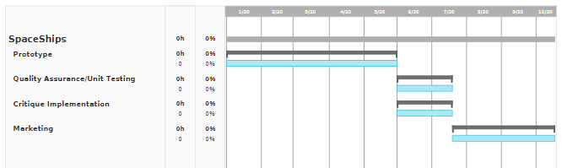Beyond unit testing and quality assurance, the project would benefit from further research into the needs of the potential clients to ensure that all possible requirements are met, and to have more complete understanding of the full scope of the project. Another process that would be beneficial to our research would be to analyse companies in similar industries, both to gather inspiration from their own implemented features, as well as to ensure that features similar to our own are at a lower quality or of equal quality to our own. Another possible step could be consulting industry professionals to enquire about qualities that they would make use of in such a project. After all of these processes the final step would be bringing the project to the open market and finding a way to market to our targeted demographic, the methods of which could vary, such as directly reaching out to companies, or, advertising using a third-party service such as Google AdSense.

Risk Analysis

As a young team, there are many risks that must be take into consideration. Among them are issues such as a lack of clients and the competition in our field. Our software will undoubtedly have to face competition from other software developers in the industry. Our first step in mitigating such risks is to identify them.

Our current assessment of existing risks includes:

1. Young team which is relatively inexperienced and may not have a full understanding of the nature of the marine logistics market within the North Sea oil and gas industry;
2. Failure to generate interest amongst operators / no up-take from operators. Without their interest and support, the ability to launch SpaceShips will be impacted;
3. Other software products who deliver similar services to the oil and gas industry. As the industry seeks means to become more efficient, there will likely be other competitors in the market;
4. Contractual requirements between operators and logistics providers which makes access to passing vessels restrictive and complex;
5. Resistance from logistics providers who inherently benefit from inefficient working practices and demand from operators.

Conclusion

The primary objective of our application is to make sourcing offshore service vessels simpler and more cost effective. Our application will be available in over three different languages and accessible to users onshore and offshore for £1,000 per month. Our application will enable operators to communicate with one another, view passing vessels now and in the future, negotiate and bid for spare deck space, as well as send payments. By using our software, you will not only save money but will be helping to reduce the overall carbon footprint of the energy industry.

Bibliography

(1) Oil and Gas Authority 2018, UKCS Operating Costs in 2017, Oil and Gas Authority, Viewed on 24/11/19, <<https://www.ogauthority.co.uk/media/5325/ukcs-operating-costs-a5-v2.pdf>>.

(2) Wingrove, M 2019, The North Sea: is that a recovery on the horizon?, Riviera Maritime Media, Viewed on 24/11/19, <<https://www.rivieramm.com/opinion/the-north-sea-is-that-a-recovery-on-the-horizon-22223>>.

(3) International Maritime Organization 2014, Third IMO GHG Study 2014, International Maritime Organization, Viewed on 22/11/19, <<http://www.imo.org/en/OurWork/Environment/PollutionPrevention/AirPollution/Pages/Greenhouse-Gas-Studies-2014.aspx>>.

(4) Rouse, M 2018, The IT pro’s guide to mobile app delivery, TechTarget, Viewed on 22/11/19, <<https://searchsoftwarequality.techtarget.com/definition/native-application-native-app>>.

(5) Casserly, M 2019, iPhone vs Android market share, Macworld, Viewed on 22/11/19, <<https://www.macworld.co.uk/feature/iphone/iphone-vs-android-market-share-3691861/>>.

(6) Appinventiv Technologies 2018, Key Challenges Faced in Developing Multilingual Mobile Apps, Upwork, Viewed on 22/11/19, <<https://www.upwork.com/hiring/for-clients/key-challenges-faced-developing-multilingual-mobile-apps/>>.

(7) Twinkle 2019, How Much it Costs to Build an App Like Uber?, MOBILE APP DAILY, Viewed on 13/10/19, <<https://www.mobileappdaily.com/uber-app-development-cost>>.

(8) Spire 2019, Flexible and transparent pricing, Spire Maritime, Viewed on 13/10/19, <<https://maritime.spire.com/pricing/>>.

(9) Microsoft 2019, Azure SQL Database pricing, Microsoft Azure, Viewed on 22/11/19, <<https://azure.microsoft.com/en-gb/pricing/details/sql-database/managed/>>.

(10) OGUK 2019, Oil And Gas Operating Members, viewed on 25/11/19, <<https://oilandgasuk.co.uk/operator-members/>>

(11) Wikidot 2019, List of oil production platforms, viewed on 25/11/19, <<http://abarrelfull.wikidot.com/list-of-oil-production-platforms-in-the-uk>>

(12)AMLA website, Petersons vessel sharing service, viewed on 25/11/19,

<[http://www.amla.uk](http://www.amla.uk/)>

(13)PlanSea website, RGU spinout for fleet planning, viewed on 25/11/19,

<<https://www.plansea.co.uk/company/>>

Appendices

FRANCESCO ROLANDO

110D Hutcheon Street

AB25 3RU

07586574309 | [f.rolando@rgu.ac.uk](mailto:f.rolando@rgu.ac.uk)

PROFILE

Second year student of Computing Science at the Robert Gordon University with a diploma of Perito in Electronics and Telecommunications.

Practical experience in agricultural mechanics gained from 3 years of work in a workshop.

Looking for summer internships and stages in order gain experience in programming.

KEY SKILLS

* Knowledge of programming language Java
* Knowledge of Database design and SQL programming
* Basic knowledge of programming languages C++ and Assembly
* Basic knowledge of programming language JavaScript
* Basic Knowledge of the programs “R” and “Processing” and their programming languages
* Fair knowledge of the hardware platform “Arduino” (Programming and Automatism creation)
* Basic Ethical Hacking knowledge

WORK EXPERIENCE

Mechanic | Meccanica Olivieri May 2015 to Aug 2018

Owned by Olivieri Graziano, this is an Italian workshop able to satisfy the requests of various agricultural and motorway companies

Main tasks:

* Mechanic
* Welder
* Lathe operator
* Iron worker
* Painter
* Actively worked to repair, modify and maintain agricultural machinery
* Designed and built mechanic part and agricultural machinery

EDUCATION & QUALIFICATIONS

Guglielmo Marconi institute, Tortona (AL), Italy – Diploma

Graduated as Perito in Electronics and Telecommunications (grade: 70/100) July 2014

Courses:

Programming, Technology Drawing and Design, Electronics, Electrotechnics, English, Italian, History

ADDITIONAL INFORMATION

Other Skills: Native speaking Italian; achieved IELTS Academic (grade: 6.5); Italian Licence holder (B category)

REFERENCES

References available on request.

Monika Sahajdakiewicz

32 Summerfield TerraceTop Right

Aberdeen

Aberdeenshire

United Kingdom

AB24 5JH

+48 509 646 116 | m.sahajdakiewicz@rgu.ac.uk | www.linkedin.com/in/monika-sahajdakiewicz-514aa9196

PROFILE

Enthusiastic student with strong learning skills and creative mind, currently enrolled on Stage 2 Digital Media Course. Hard working, organised and with a keen eye for details, now seeking an opportunity to gain positive work experience in relevant industry, in order to be able to keep on improving her abilities.

EDUCATION & QUALIFICATIONS

2018 – now Robert Gordon University, Aberdeen – Digital Media Course

Grades:

Computing Information Systems (A)

Digital Media Design (B)

Digital Graphics Techniques (A)

Problem Solving And Modelling (A)

Introduction To Computing For Digital Media (A)

* Advanced MS Word and PowerPoint skills developed within an academic environment to highly professional standard
* Confident user of Adobe Illustrator and Adobe Photoshop, demonstrated in designs and graphics made using those softwares
* Great attention to details
* Effective quick learner
* Good understanding of Processing and C# programming languages

WORK EXPERIENCE

Graphic Designer |Warsaw University of Technology – Faculty of Chemistry April 2019 to May 2019

The Warsaw University of Technology is one of the leading institutes of technology in Poland and one of the largest in Central Europe.

Responsible for creating a graphic design of a poster for an annual science festival organised by Chemical Scientific Society ‘Flogiston’

* Successfully designed an attractive poster, keeping in mind the employer’s needs
* Carefully prepared the design for printing

ADDITIONAL INFORMATION

Other Skills:

Basic knowledge of database systems and SQL, Basic knowledge of web design and development

Awards:

Sponsored Prize for academic excellence for Digital Media Stage 1 [2019], Prime Minister´s Prize for academic excellence in the second year of high school [2015]

Languages:

Polish (Native), English (IELTS Certificate Level C1 [2017]), French (Basic)

INTERESTS

Digital painting, horseback riding, hand-sewing, reading

REFERENCES

References available on request.

Nicholas Rennie

17 Montgarrie Road, Alford, Scotland, AB33 8AE

Mobile: 07769754576

Email: Nicholas.rennie02@gmail.com

D.O.B: 02/06/2000

PERSONAL STATEMENT

I am a very innovative, enthusiastic and outgoing individual who always strives to achieve tasks to the best of my ability. I am a friendly and professional person that finds myself being able to establish long-term, positive and fun relationships with managers, co-workers and customers. Being a very flexible worker means I find it easy to learn new skills, develop existing ones and adapt quickly to changes within the workplace. I am a very articulate communicator when both enthusiastically leading a team and contributing to one, I also enjoy making decisions and implementing new ideas. Combining my passion and interest for meeting and interacting with new people I naturally find myself promoting products very easily to customers. I pay very close attention to detail, which helps me to achieve deadlines and have a natural ability to work well under pressure.

EDUCATION

Attended Alford Academy (Alford, Aberdeenshire):

National 5 (2016);

Maths - B

English - C

Graphic Communication - C

Physics - B

Physical Education - C

Computing Science - A

Higher (2017-2018);

Computing Science – B

Graphic Communication – C

Business Management - C

Maths - C

Physics - C

FURTHER EDUCATION

I am currently ongoing study towards a Bsc of Computer Science at Robert Gordons University where I am currently in my 2nd year

EMPLOYMENT

Sales assistant/Supervisor: August 2016 - September 2017

I worked as a sales assistant at Icon Stores convenience store for just over a year, before this I worked in the same position at this store but under different owners. My duties included creating window displays, helping with the book keep, assisting customers with their queries and purchases, cash handling, dealing with telephone enquiries and stock taking. Having had this job, I have gained a very good work ethic and understand the responsibilities of holding a part time job. I achieved understanding the importance of good communication and teamwork to hit sales targets and to provide very good customer service.

Cashier: September 2017 – September 2018

I have also worked as a cashier at my local Indian Takeaway where my duties consisted of Cleaning, taking orders, money handling, handling food and telephone orders. From this part time job I learned how to perform efficiently and quickly under pressure on the busy nights of the week and work together with my colleagues to ensure quality of service.

Train Guard: April 2017 – October 2017

During the spring and summer I worked as a train guard at my local historic railway where my duties were interacting with customers, handling money, decoupling and recoupling the train and assisting with problems that would arise from the train, this job also helped teach me how to work In a team as it was necessary to ensure customer safety on board the train and on the platforms.

ACHIEVEMENTS

I currently Hold a first degree black belt in Choi Kwang Do where I have also been trained to be an Assistant Instructor, during classes I would teach the younger students their techniques and assist with any problems, this has helped teach me how to be a strong leader and a patient person when dealing with others.

REFERENCES

References available on request.

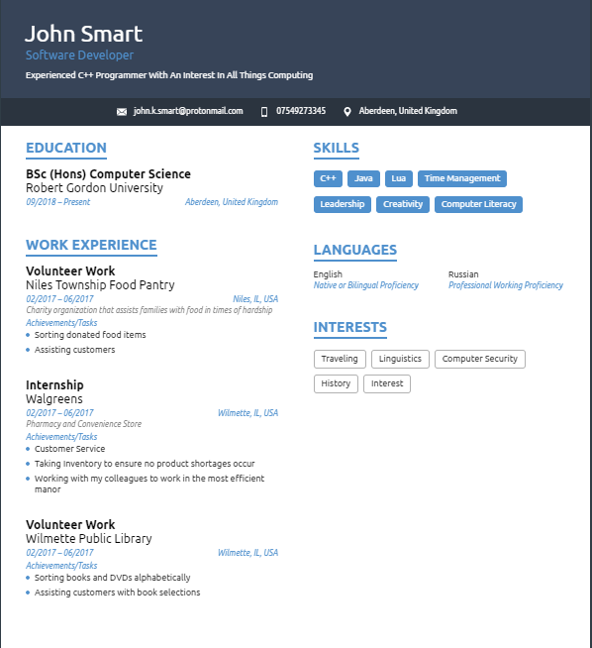

PAULA JONES

10 Dunnottar Road

Ellon

AB41 9JF

Mobile: 07875020835

Email: pmejones86@gmail.com

NI Number: JH189040A

Date of Birth: 17th July 1986

PERSONAL STATEMENT

I am hard working, enjoy learning new things and pick them up quickly.  I enjoy working in a team, but I am very capable of working on my own initiative. I am also responsible and reliable. I have a thirst for knowledge and enjoy making new friends. I consider myself to be flexible in my approach to work, and able to adapt to changes to situations as they arise.  I am a confident person with the ability to talk to different people from all walks of life.

EDUCATION

HND Interactive Media - Achieved at Moray College UHI, Elgin

SVQ, Construction: Woodmachining Level 2 - Achieved at Edinburgh Telford College, Edinburgh, 2006

Banff Academy, Banff

EMPLOYMENT

Blackwells, Aberdeen – Book Seller

* Assist customers in choosing the correct book.
* Carrying out transactions on the till.
* Staking shelves.

Caroline Watt, Ellon - Child Care

March 2019 - Present

* Helping to look after two boys with autism

 OCS, Aberdeen - Security Guard

October 2014 - May 2019

* SIA licence.
* Performing site patrols.
* Reception duties;
  + Using switch board,
  + Signing in visitors,
  + Booking taxi,
  + Sorting outgoing, using Franking machine.
  + Sorting incoming mail.
* Keeping page work up-to-date, clear and understandable.
* Working in a gatehouse.
* Logging vehicles in and out.
* Working entrance and exit barrens.

Pizza Express, Aberdeen - Pizzaiolo Chef

January 2014 – September 2014

* Working within a very fast paced and demanding kitchen environment.
* Trained to open and close the kitchen.
* Constantly having to be aware of all company policies regarding health and safety.
* Adherence to company rules, procedures and standards, but also to challenge standards and come up with new ideas.

Asda, Elgin - Counters

June 2008 – January 2014

* Working within a demanding and busy customer orientated environment.
* Trained to open, close and work on the Pizza, Fish, SORM (serve over meals) and Deli counters.
* Gain knowledge in stoke take and ordering.
* Gain knowledge in stock replenishment.
* Gain high customers service skills including 100% on Happy to Help.

David Urquhart Joiners, Portsoy - CNC worker

March 2007 – August 2007

* Knowledge of working a CNC machine for the casting of stairs
* Preparing wood
* Fitting stairs together in workshop
* Keeping my area of workshop safe and clean

Buckingham Joinery, Cornhill - Wood machinist

August 2004- September 2006

* Worked for a small company where I did all duties:
* De-nailing timber
* Cutting of timber,
* Setting up and using of machinery,
* Fitting and finishing of end product.
* Gained knowledge of working on site fitting finished items.
* Stocktaking and reordering.
* Keeping workshop safe and clean

ADDITIONAL INFORMATION

I have a SIA Security Licence

I have a full clean driving licence and own my own car.

I was Class Representative in College during my HNC.

I enjoy walking, driving, reading, watching movies, playing video games and socialising.

REFEREES

References can be supplied on request.

/Volumes/1910299/Project/Gregor's Resume.pdf